使用方式：
- 直接new构造，然后通过需要动画控件的设置动画方法，开始动画。
// 构建3D旋转动画对象,旋转角度为0到90度
Rotate3dAnimation rotation = new Rotate3dAnimation(0, 90, centerX, centerY,310.0f, true);
// 动画持续时间500毫秒
rotation.setDuration(500);
// 动画完成后保持完成状态
rotation.setFillAfter(true);
mRelativeLayout.startAnimation(rotation);
- 先建一个空动画类，设置这个空动画的动画监听，在监听事件中，去启动动画效果
Animation rotation=new Animation() {};
rotation.setAnimationListener(new RotateToTheSecondImageViewAnimationListener());
.....
class RotateToTheSecondImageViewAnimationListener implements AnimationListener {
@Override //动画开始。也可以做另一个动画
public void onAnimationStart(Animation animation) { }
@Override //动画结束
public void onAnimationEnd(Animation animation) {
//动画完成后展示另外的图片
mImageView.setImageResource(R.drawable.a22);
// 获取布局的中心点位置,作为旋转的中心点
float centerX = 0 ;
float centerY = mRelativeLayout.getHeight()/2 ;
// 构建3D旋转动画对象,旋转角度为270到360度
Rotate3dAnimation rotation = new Rotate3dAnimation(-90, 0, centerX, centerY,310.0f, false);
// 动画持续时间500毫秒
rotation.setDuration(500);
// 动画完成后保持完成状态
rotation.setFillAfter(true);
rotation.setInterpolator(new AccelerateInterpolator());
mRelativeLayout.startAnimation(rotation);
}
@Override //动画重复
public void onAnimationRepeat(Animation animation) { }
}

Rotate3dAnimation参数解释：

第一个：图片动画的开始位置。范围是-360到360，但其实真正有效的是-180到180。0度是屏幕平面，90度和270度等价，表示从手机背面垂直于0度面。-90度表示从手机正面垂直0度面。
第二个：图片动画的结束位置
第三个：图片x轴旋转中心点。
第四个：图片y轴旋转中心点
第五个：图片z轴移动距离（直观上是放到与缩小）
第六个：图片最后是否翻转
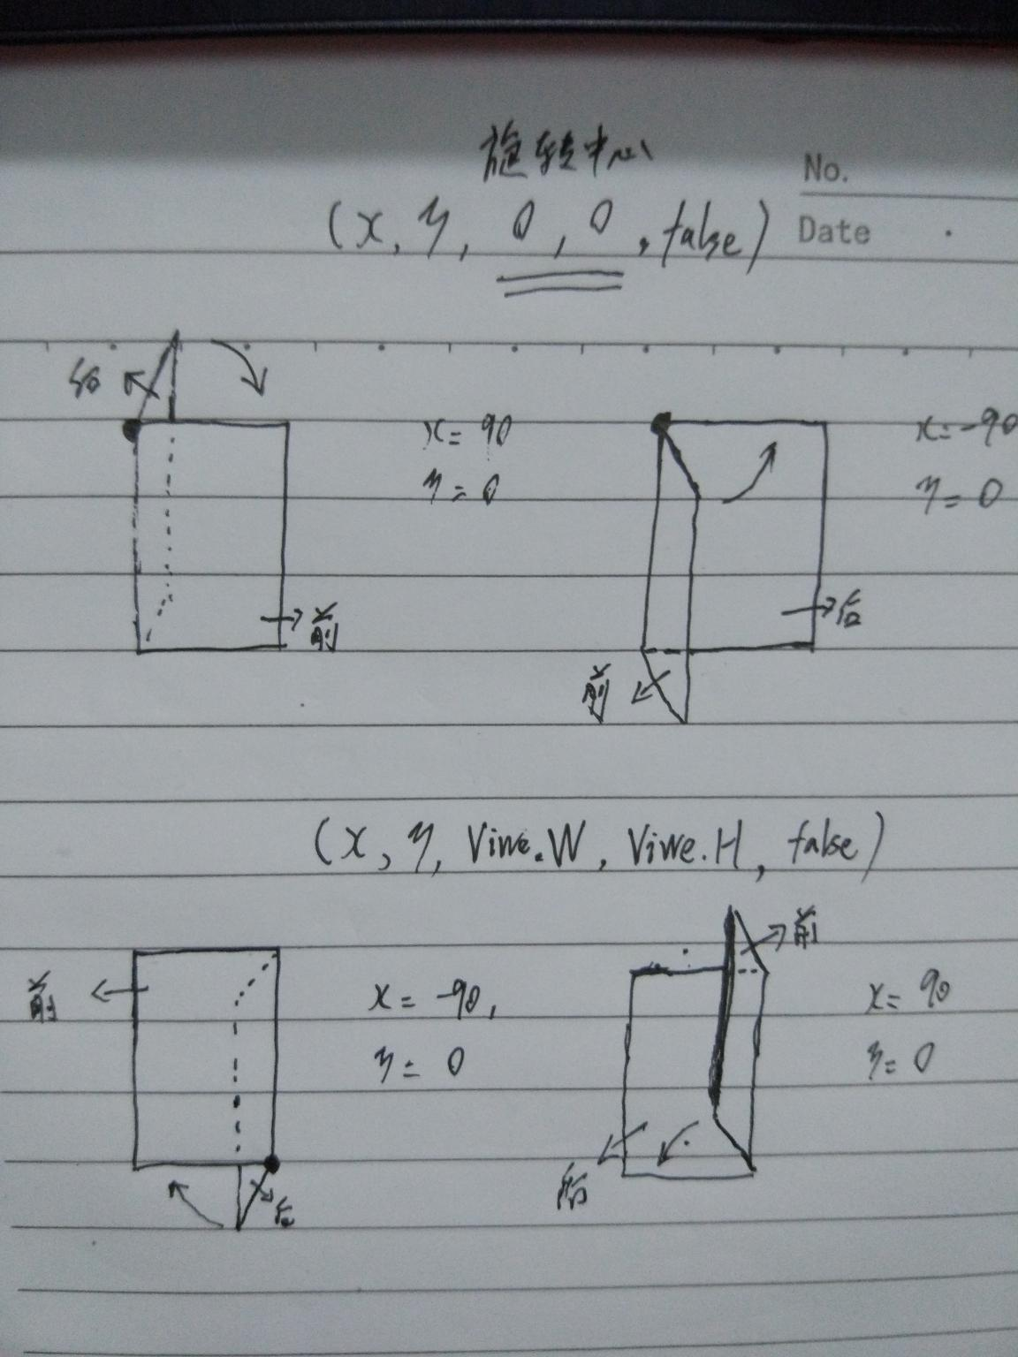
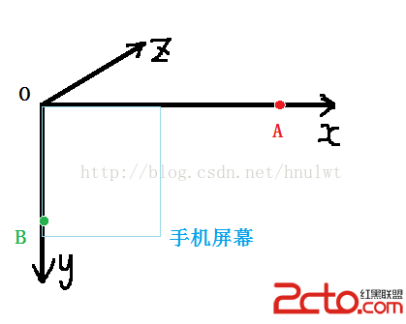
进行变换：camera.rotateX(60);

进行变换： camera.rotateY(60);

进行变换：camera.rotateZ(-60); （这里是-60哈）



rotateX:以(0.0)为中心，绕X轴进行选择
rotateY:以(0.0)为中心，绕Y轴进行选择
rotateZ:以(0.0)为中心，旋转（此处和Matrix旋转原理一样，只不过反向相反，为逆时针）
遵循“正，逆时针转；负，顺时针转”
源码：
public class Rotate3dAnimation extends Animation {
private final float mFromDegrees; private final float mToDegrees;
private final float mCenterX; private final float mCenterY;
private final float mDepthZ; private final boolean isReverse;
private Camera mCamera;
/**
* Creates a new 3D rotation on the Y axis. The rotation is defined by its
* start angle and its end angle. Both angles are in degrees. The rotation
* is performed around a center point on the 2D space, definied by a pair
* of X and Y coordinates, called centerX and centerY. When the animation
* starts, a translation on the Z axis (depth) is performed. The length
* of the translation can be specified, as well as whether the translation
* should be reversed in time.
* @param fromDegrees the start angle of the 3D rotation 开始角度。）0度即面向我们的屏幕面，-90度逆时针，+90度顺时针。
* @param toDegrees the end angle of the 3D rotation 结束角度
* @param centerX the X center of the 3D rotation 旋转中点X
* @param centerY the Y center of the 3D rotation 旋转中点Y。
* 这两个可能难以理解，其实想象个空间3维坐标系，把这个当做（x，y）当作坐标系原点。当（x,y）=(0,0)时，是俯视图片旋转。当（x,y）=(图宽,图长)时，是俯视图片旋转。
* @param depthZ 深度，在Z轴上移动多少。直观上是原图缩放多少。为正是缩小，为负是放大。
* @param reverse true if the translation should be reversed, false otherwise true为翻转，false不翻转。实测对图像没影响，只有depthZ设置后，才会缩放图片 */
public Rotate3dAnimation(float fromDegrees, float toDegrees,
float centerX, float centerY, float depthZ, boolean reverse) {
mFromDegrees = fromDegrees; mToDegrees = toDegrees;
mCenterX = centerX; mCenterY = centerY;
mDepthZ = depthZ; isReverse = reverse; }
@Override
public void initialize(int width, int height, int parentWidth, int parentHeight) {
super.initialize(width, height, parentWidth, parentHeight);
mCamera = new Camera(); }
@Override
protected void applyTransformation(float interpolatedTime, Transformation t) {
final float fromDegrees = mFromDegrees;
float degrees = fromDegrees + ((mToDegrees - fromDegrees) * interpolatedTime);
final float centerX = mCenterX; final float centerY = mCenterY;
final Camera camera = mCamera; final Matrix matrix = t.getMatrix();
camera.save();
if (isReverse) { camera.translate(0.0f, 0.0f, mDepthZ * interpolatedTime);
} else { camera.translate(0.0f, 0.0f, mDepthZ * (1.0f - interpolatedTime)); }
camera.rotateY(degrees); camera.getMatrix(matrix);
camera.restore(); matrix.preTranslate(-centerX, -centerY);
matrix.postTranslate(centerX, centerY);
}
}

